

Yet Another Streaming Service (YASS)

User Guide

© Three Bum Lads and a Crossfit Fairy

Stephen Cline, Sean Lamont, Liana Madden, Jeremy Martin

December/2019

Table of Contents

Introduction 2

Getting Started 2

System Requirements 2

Quick Start 2

Software Usage 2

Click to document main user interface (main menu) 2

Glossary 2

# Introduction

YASS allows you to scroll through our endless collection of 249 movies without having to waste hours of your time watching the actual movie. Our movie streaming service has a special function for those in a relationship. You already spend so much time waiting for her to make up her mind about where she wants to eat, now you can choose her mood in our “In A Mood” page and it will narrow down your movie choices to just 16 or less movies. This makes the decision process quick and painless for all involved.

Yet Another Streaming Service(YASS) allows you to:

* Scroll through an endless collection of 249 movies
* Choose a movie from our Recommended List that is made specifically for the user
* Search through our collection of movies using keywords, actor’s names, director’s names, or genres in the search bar
* Change your name, email, and password conveniently on the account page
* Scroll through your viewing history composed of every movie that you’ve watched
* Choose a mood from the “In A Mood” page that will give you 16 or less movies to choose from

The Yet Another Streaming Service (YASS) is accessible using Java 1.8 and SceneBuilder. This was required for the class so it was the best option for the interface.

# Getting Started

## System Requirements

Java SE Runtime Environment 8

## Quick Start

1. Begin by entering your login information on the sign-in page to gain access to the streaming service.  
   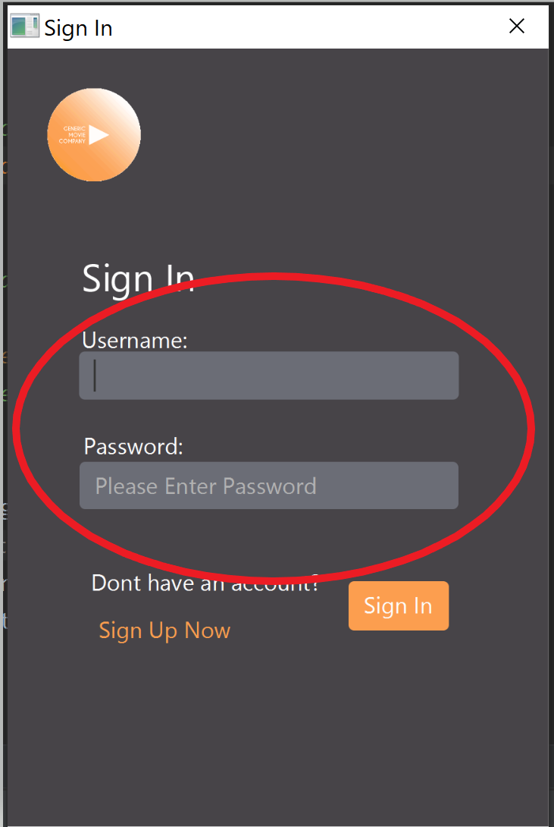
2. If you are new to YASS, click on the Sign Up Now button to create a new account.

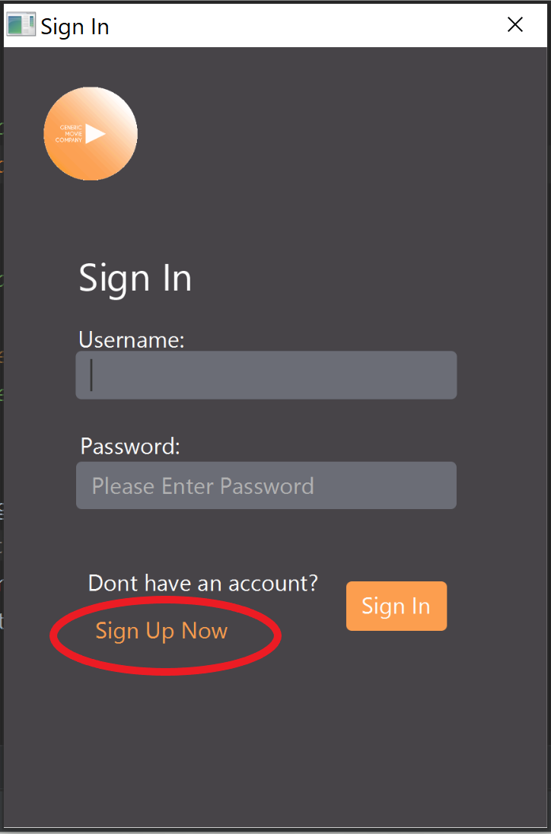

1. Fill out all of the required information on the sign-up page to create a new account. You must be 13 years of age or older to create a new account.

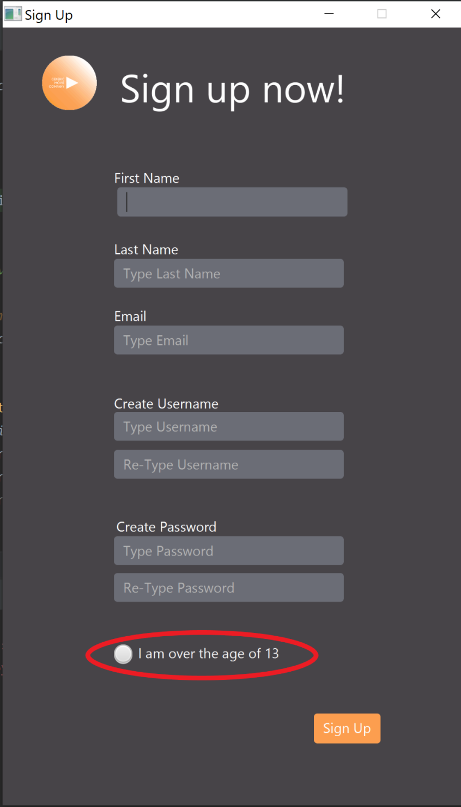

1. Click the Sign-Up button to create your account and it will bring you back to the Sign-In page.

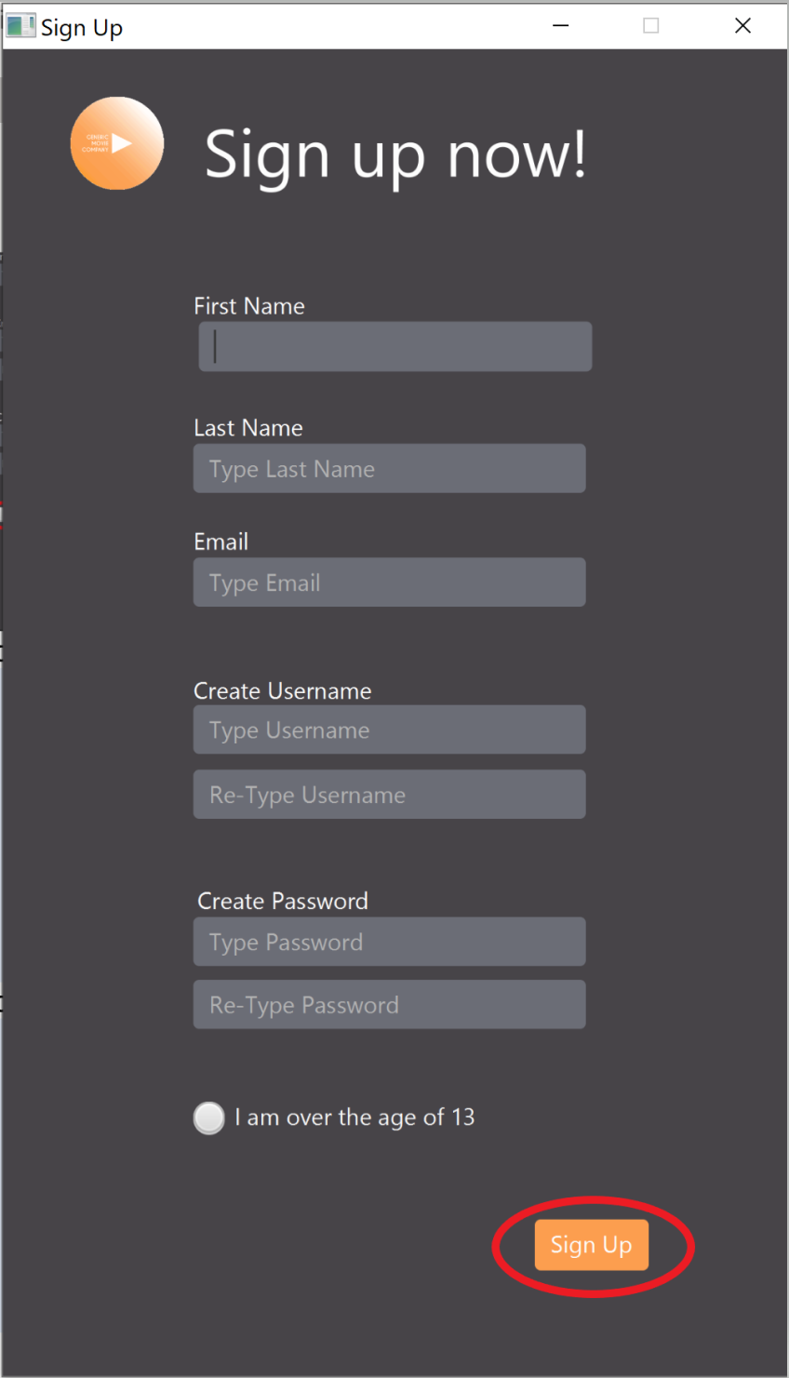

1. Fill out your information and click the Sign-In button. This will bring you to your personal Home page.  
   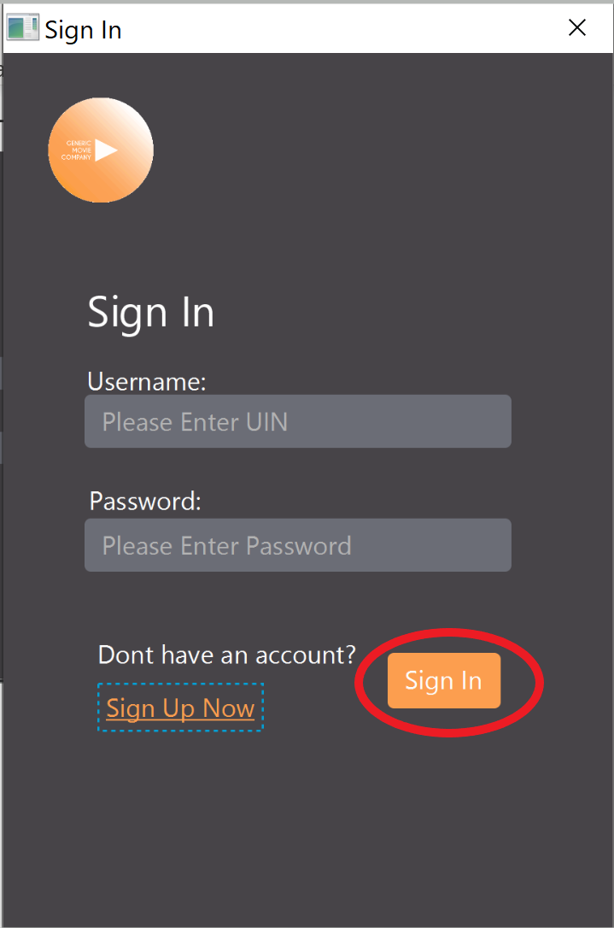
2. Begin scrolling.  
   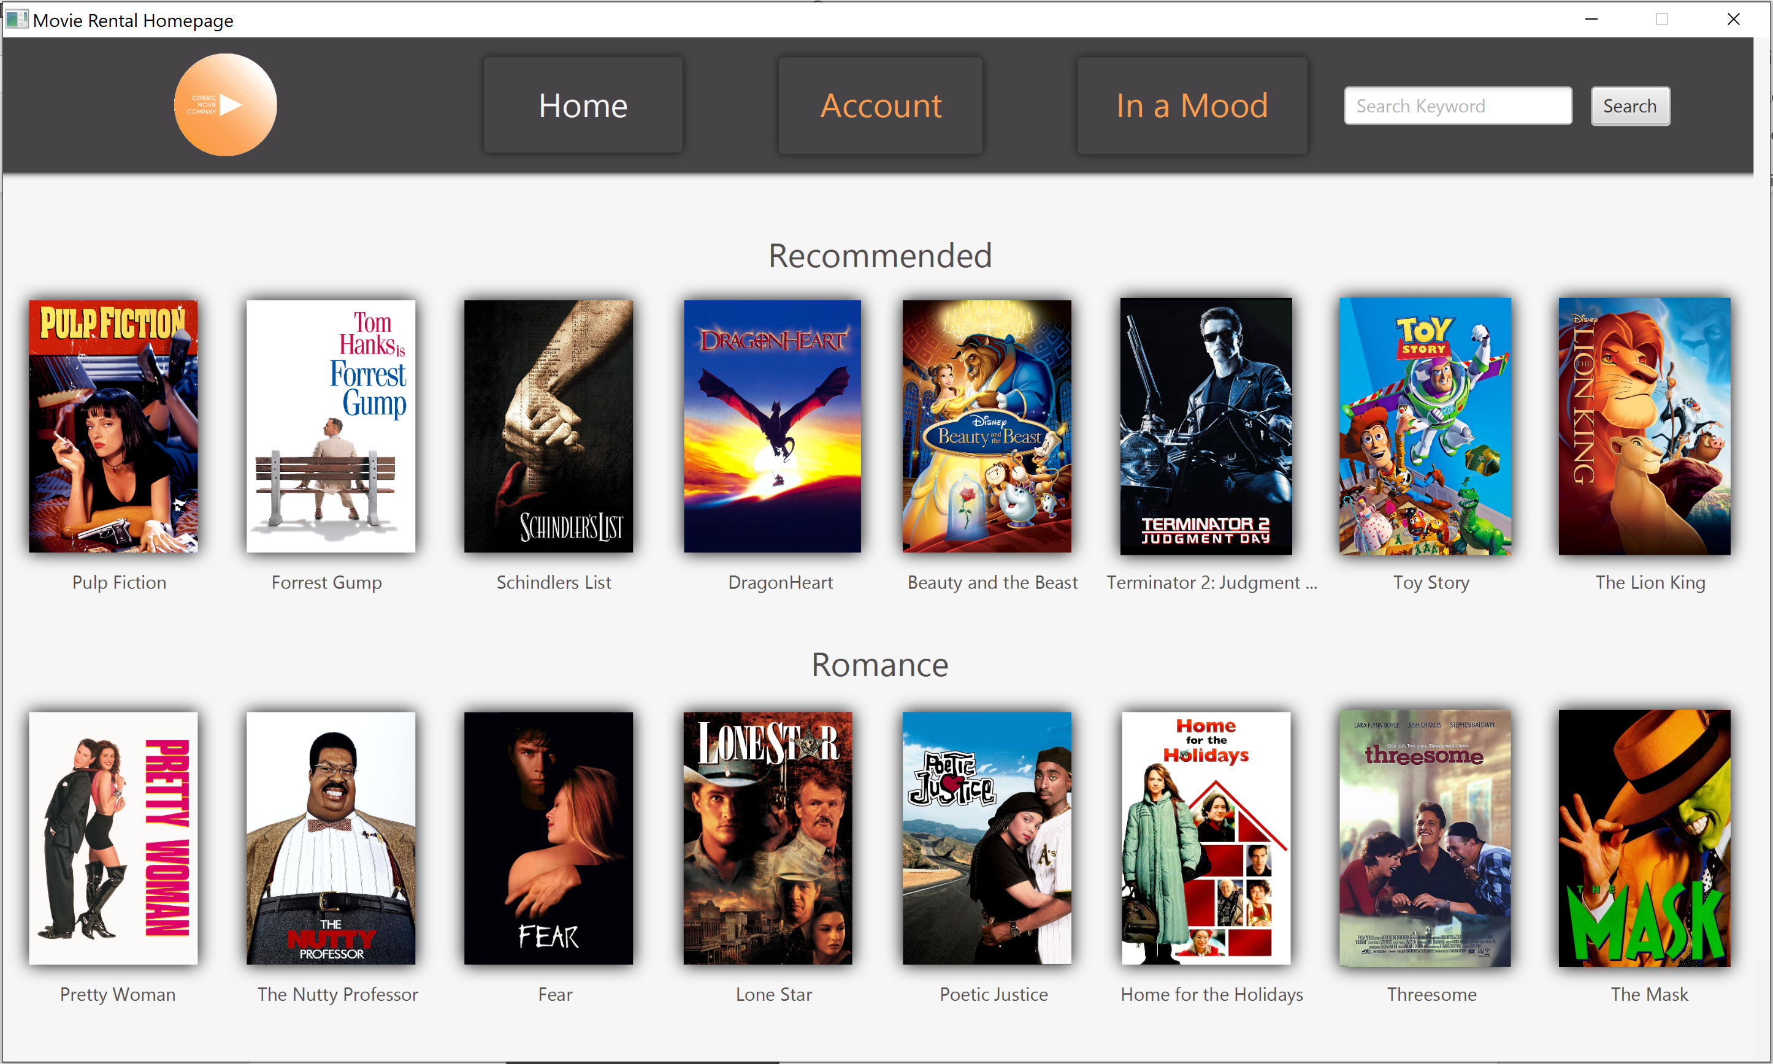

# 

# Software Usage

**Home Page:**

## 

The Home page allows you to scroll through 5 categories of movies with 8 movies in each in category. You can click on a movie poster to see the details of that specific movie.

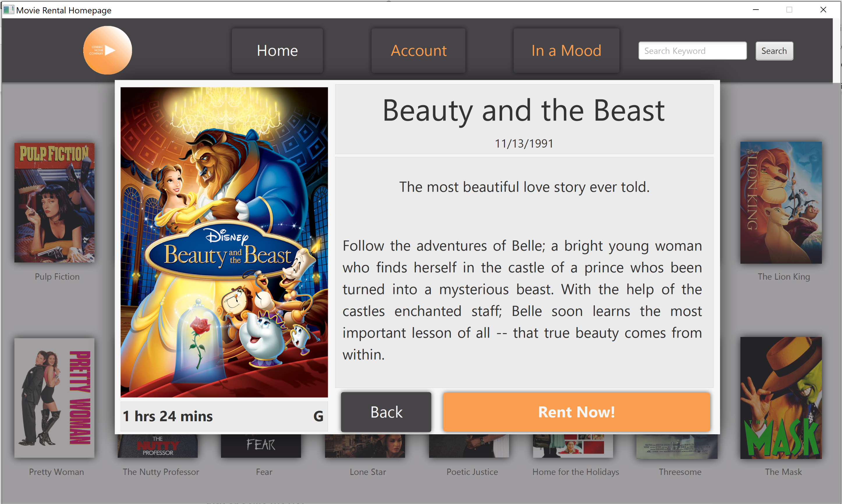

From the details page you can choose to go back and continue searching through movies, or you can choose the Rent Now button to watch the movie.

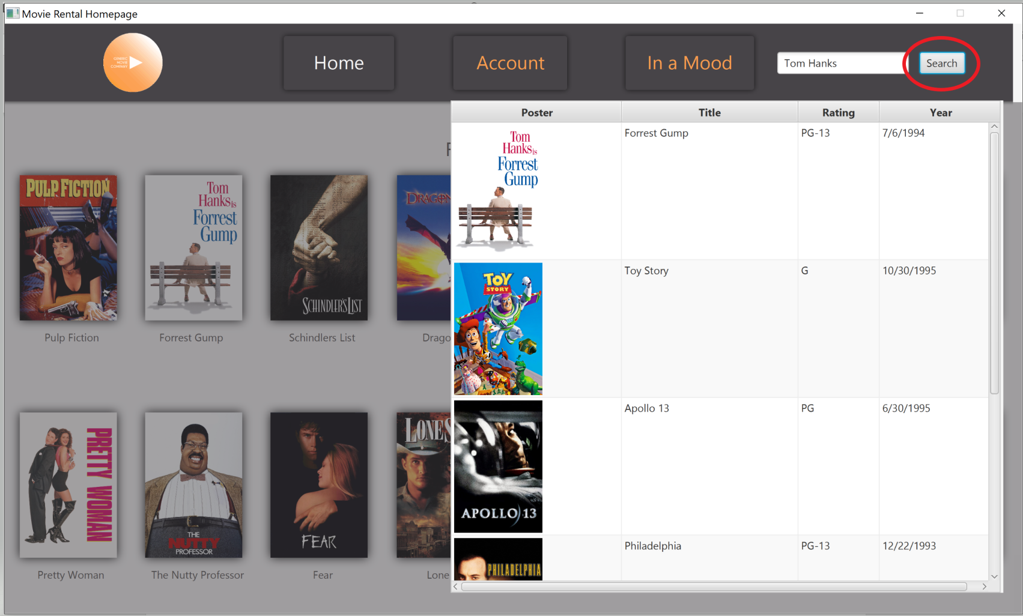

The search bar on the Home page allows you to type in keywords such as names of actors, names of movies, or genres. This will pull up any movies that have the keywords you typed in. You can then click on any of the movies that were found and the details page will come up on that movie. If you aren’t satisfied with the movie that you choose, you can go right back to your current search.

**Account Page:**

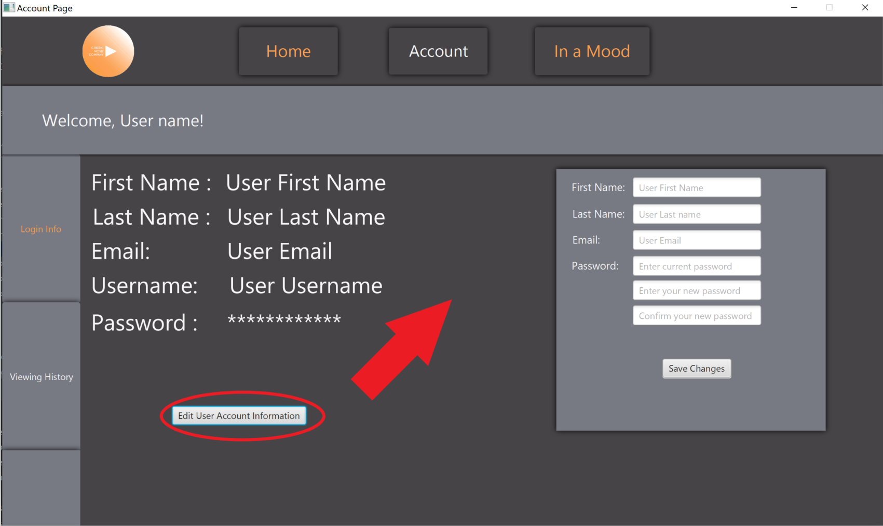

The account page shows your user information and allows you to change your name, email, and password by clicking on the Edit User Account Information button.

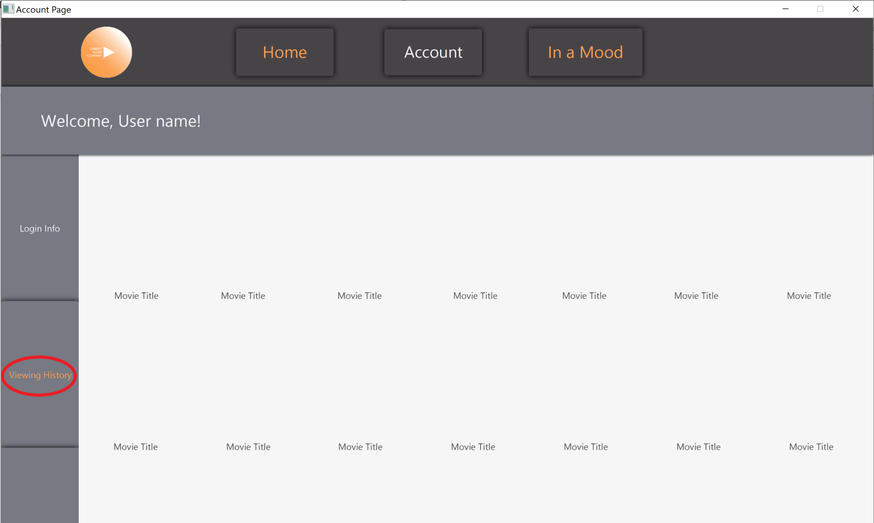

By clicking on the Viewing History button you can see all of the movies that you have watched completely or partially through.

**In A Mood Page:**

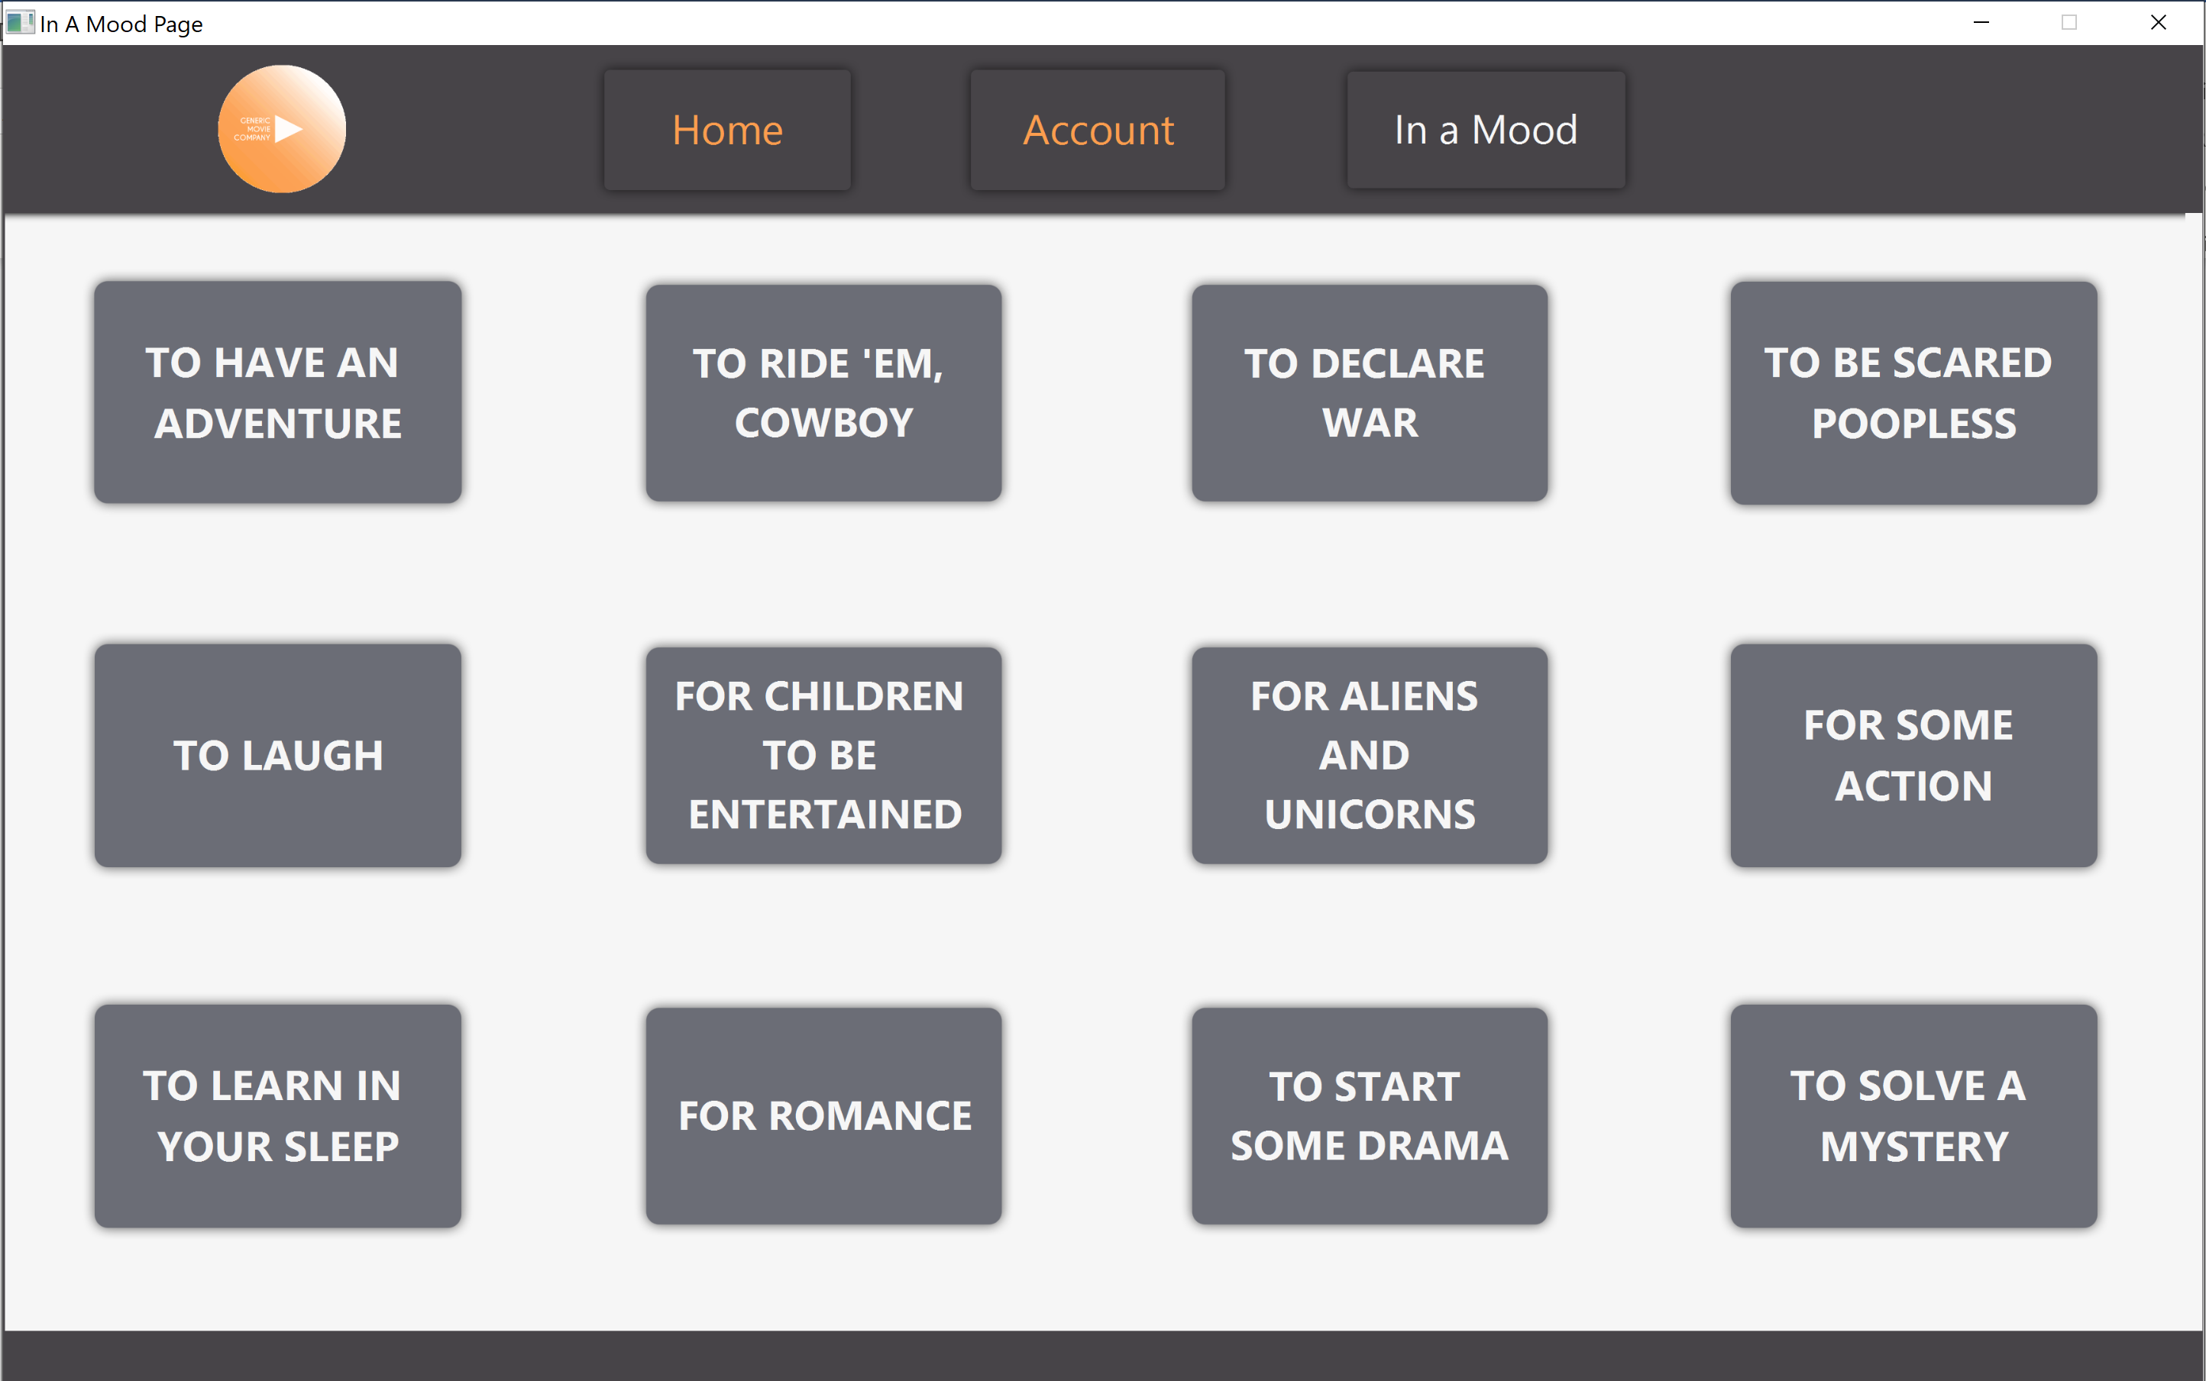

The In A Mood page has 12 buttons that you can click on based on the mood of you or anyone that is watching.

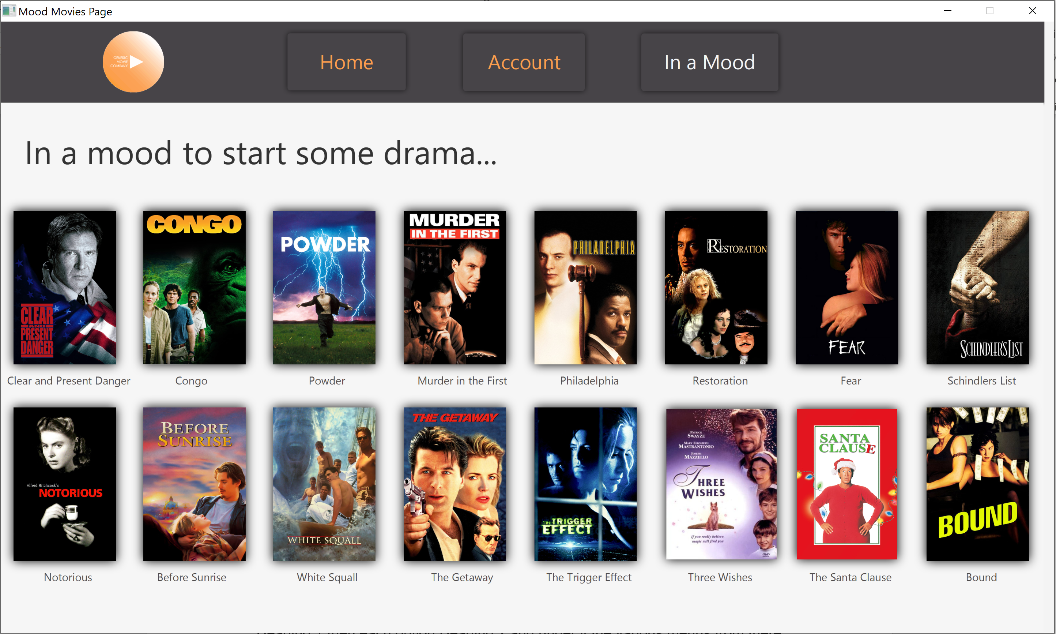

You can select between 16 or less movies in the selected mood.

# Glossary

**YASS- Yet Another Streaming Service**